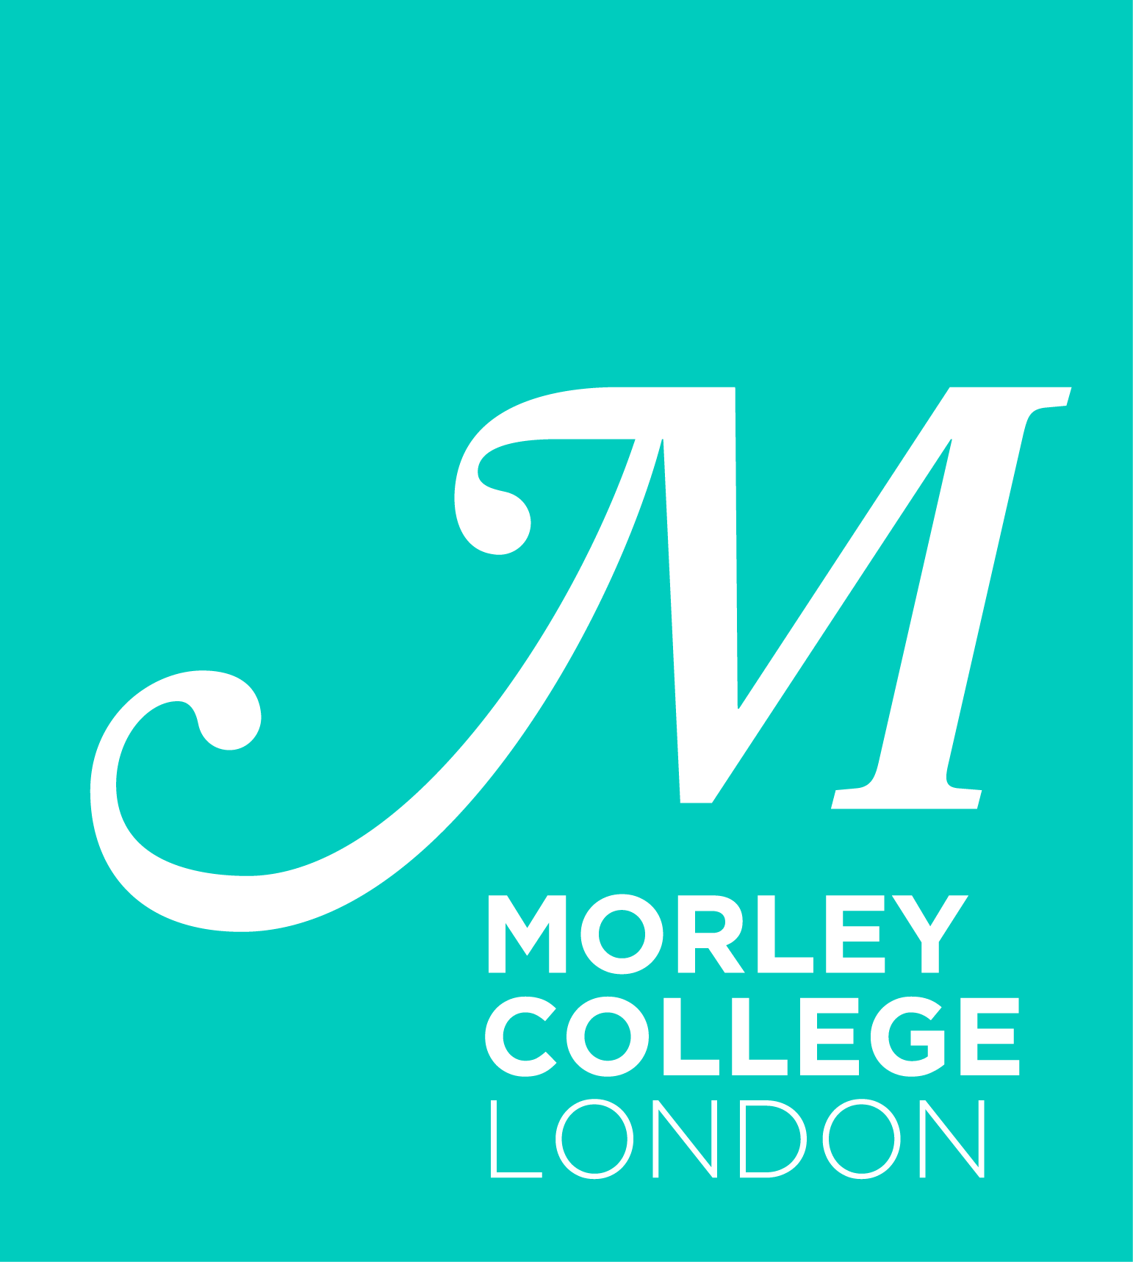
MORLEY OPERA SCHOOL

& INTRODUCTION TO OPERA PERFORMANCE

Audition Application 2023 / 2024

Applying for (tick your preferred option):
- Introduction to Opera Performance □
- Morley Opera School □

Name: | Attach passport photo here (OPTIONAL):
Address: | Attach passport photo here (OPTIONAL):
Type of Voice (please tick as appropriate):
SOPRANO □ MEZZO-SOPRANO □ COUNTERTENOR □
TENOR □ BARITONE □ BASS-BARITONE □ BASS □
Range: Please indicate below the top and bottom notes you can comfortably perform
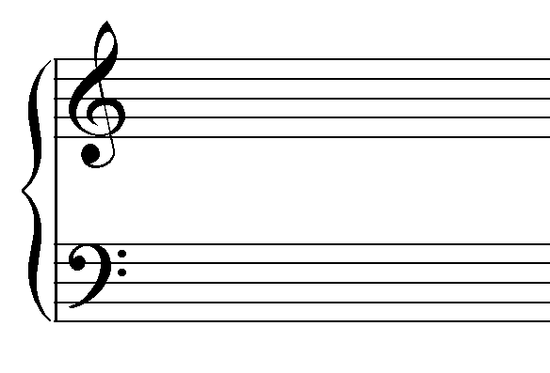
Telephone:

Mobile:
Email:

Current singing teacher :

Current vocal coach (if applicable):

Musical education: Please include any vocal/musicianship/theory/instrumental/academic
training, including qualifications/grades (if applicable)

Roles performed: (Please indicate whether staged or unstaged):

Languages spoken (please rate your knowledge as beginner/ intermediate/ advanced/ fluent):

Rehearsals: Sessions vary from week to week and schedules are published in advance.
Delete those sessions you can never attend.

Introduction to Opera Performance:
Saturdays 2-5pm

Morley Opera School:
Wednesdays 6.30-9.30pm
Thursdays 6.30-9.30pm
Saturdays 10.30am-1.30pm

Do you have any regular commitments that could create issues of availability/punctuality:

Have you studied at Morley College in the past?

Yes/No

If yes, when?

Are you currently a member of another opera group/course?

Yes/No

If yes, please state which and the rehearsal times:

Personal Statement (continue on a separate sheet if necessary)

Please outline why you would like to undertake the course, what you hope to gain from the course, what your performance ambitions are and why you think the course is suitable for you. You may include any other information you think may be of interest to the panel.

The Audition:

Live Audition:

Auditions normally take place around late June/ early July. There may be opportunity to audition in early September in case there are still places available. In case you are invited to an audition, you will be asked to prepare 2 arias of your own choice preferably in two different languages and from memory. There will be a piano accompanist in the audition.
- Submit this application form to opera@morleycollege.ac.uk
- You will then be contacted to attend a live audition and interview at our Waterloo site. The address is 61 Westminster Bridge Road SE1 7HT, London.
- You will need to prepare two contrasting arias of your own choice to sing to the panel. There will be a live accompanist at your audition.

Online Audition:

In case you are unable to make the audition dates, it may be possible to submit a recent recording instead and have an online interview. Please check by writing to opera@morleycollege.ac.uk

If auditioning online, please submit this application form alongside unedited video recordings of two contrasting arias of your choice, which you have created in the last 3 months. Your performance can include live or pre-recorded piano accompaniment, and simple recording equipment, such as a smartphone, is perfectly acceptable. You need to perform from memory, facing the camera, and the sound and image must be clear.

Please share your videos with opera@morleycollege.ac.uk, using a video link such as a private/unlisted YouTube video, and email us to confirm your submission of the application form and recordings. We do not accept videos with expiration date eg. WeTransfer, or videos that may need subscription to access, eg. Dropbox.

Upon receipt of your application form and recordings, we will contact you to arrange an online interview.

For office use:

